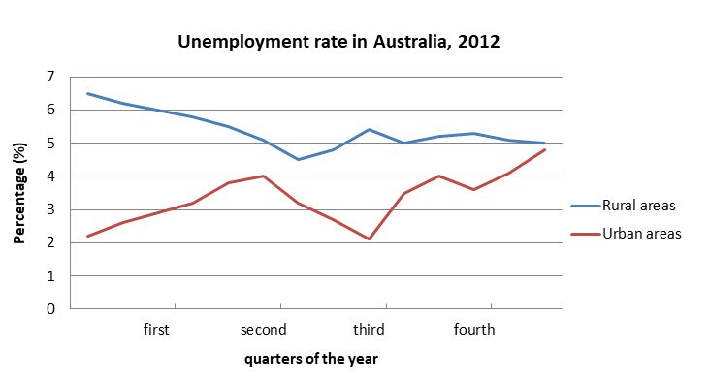

the The chart shows the rate of unemployment in Australia during 2012 overall, the rate of unemployed people in both rural and urban areas is not steady.

It is crystal clear that till the second quarter of the year , the unemployment rate doubled and in the rural area, the rate dropped by around 4 percent. then again init it raised around one and a half percent till the third quarter of the year from there it was steady till the fourth quarter at the fourth quarter the rate was slightly raised raised slightly but again till the end of the year it got down it fell where it was on the in the third quater.

However, in the urban area, the unemployment rate got down it fell by 2 percent till the third quarter by making the same employment rate from the beginning of the year but after the third quarter, the rate of unemployment rocketed through the roof by 3 percent higher.

